Tab 1
SAME Seattle Post
Board Meeting - Minutes - Thursday December 4, 2025
Time: 8:00 am – 9:00 am
* Voting Board member

Name | Position | In Attendance
Robert Schlesinger* | Post President | Y
Faith Powell | Immediate Past Post President
Fred Barker* | Post 1st VP
Zachery Pesicka* | Post 2nd VP
William Shelton* | Young Professionals VP | N
Scott Kinney* | Secretary | Y
Justin Rodgers* | Treasurer | Y
Joseph Chung | Assistant Treasurer | Y
Ryan Peterson* | Post Director (2023-2026) | Y
Nancy Yee* | Post Director (2023-2026)/Small Business Committee Co-Chair | Y
Lydia Griffey* | Post Director (2024-2027) - Strategy/Streamers/Awards POC/Meet the Chiefs Chair | Y
Al Wycoff* | Post Director (2024-2027)/Nominations Committee Chair/Engineering & Construction Camps Committee | Y
Manny Bautista* | Post Director (Fellows) (2024-2027)/Post Fellows POC
Mitch Pastizzo* | Post Director (Young Professional) (2025-2028)/Young Professionals Committee Chair
CAPT Preston Taylor | Appointed Director (2025-2026) | Y
Melissa Grasso | Communications/Post Web Master | N
Tim Pochop | Kitsap Chapter/STEM/Student Chapter | Y
Caroline Roberts | Leadership Development
Jonathan Owen | Membership Chair | Y
Ginette Chin | Mentoring
Valerie Wade | Programs Chair | Y
Josh Hamon | Programs Asst. Chair | Y
Jason Hu | Meet The Agencies Committee Chair/Projects of Excellence Committee Chair/Veterans Assistance Chair | N
John Souza | Scholarships | Y
Tony Roos | Regional Vice President
Pooja Jain | Small Business Committee Co-Chair | Y
Mason Mullins | UW Student Chapter Liaison
Liam O’Brien | Sustainability Chair/Social Media | N
Jeremy Weikel | Emergency Preparedness Committee Chair

Welcome and Announcements
- Roll call (see page 1).
- Declare quorum (4 voting members required).
- Approval November 6, 2025 Minutes.
- Approval December 4, 2025 Agenda.
- Announcements
- Old Business
  - Treasurer accounts
    - Joseph to schedule half-hour meeting with Bob, Fred and Justin to iron out log-ins for WA Department of Revenue and Constant Contact
  - Wreaths Across America participation (Melissa)
    - local cemeteries and veteran gravesites disseminated last week with an example mockup. Optional donation is $17/wreath but the main volunteer opportunity for SAME post is via volunteer manhours
    - Event is on 13DEC, start time ~0900-1000, followed by wreath handout. Typically, a second volunteer opportunity a few weeks after laying wreaths is available to remove wreaths. Board previously approved Tahoma National Cemetery in Kent and Ivy Green Cemetery in Bremerton.

- New Business
  - Scholarships Update (John Souza) -> PSESSF 2025_09Jan2025_Version 1.pptx
  - SAME re:Members software (aka Billhighway) rollout 1/12/2026
    - Consolidated financial platform for Posts: Payment Processing, Banking (FDIC insured), Spend Management, Finance & Accounting
    - Financial training 1/6/2025 1200-1330 PST
    - Events + Communications training 1/13/2026 1200-1300 PST
    - Training will be recorded and available in the training resource center.
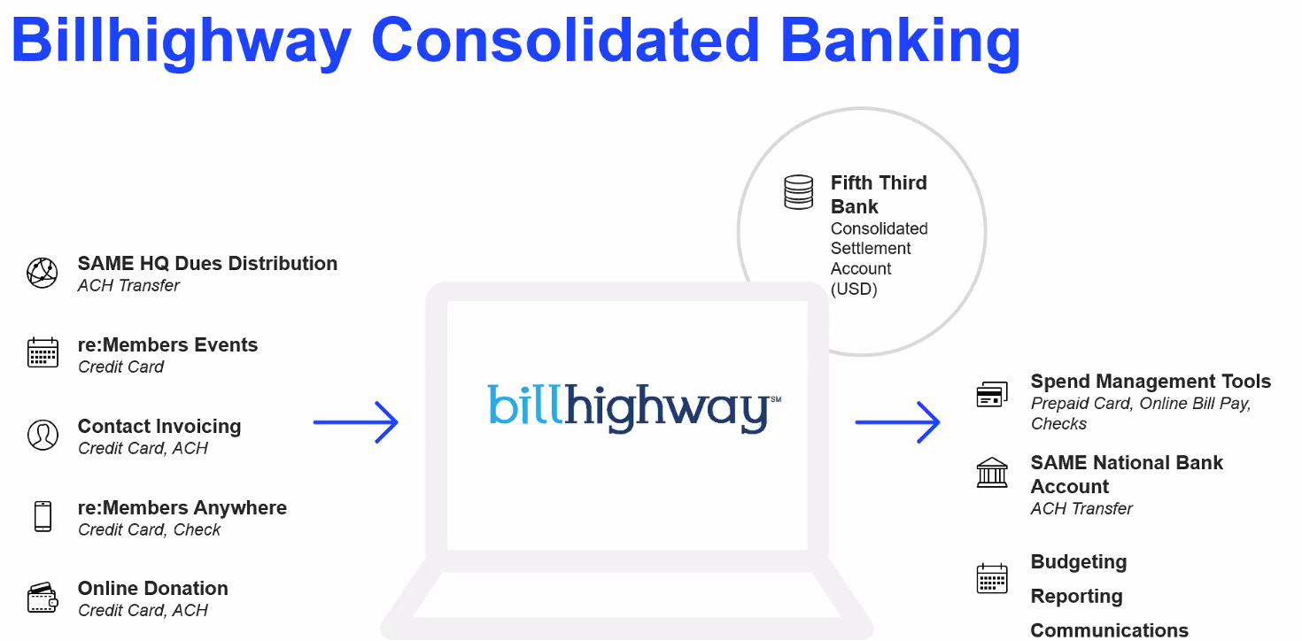

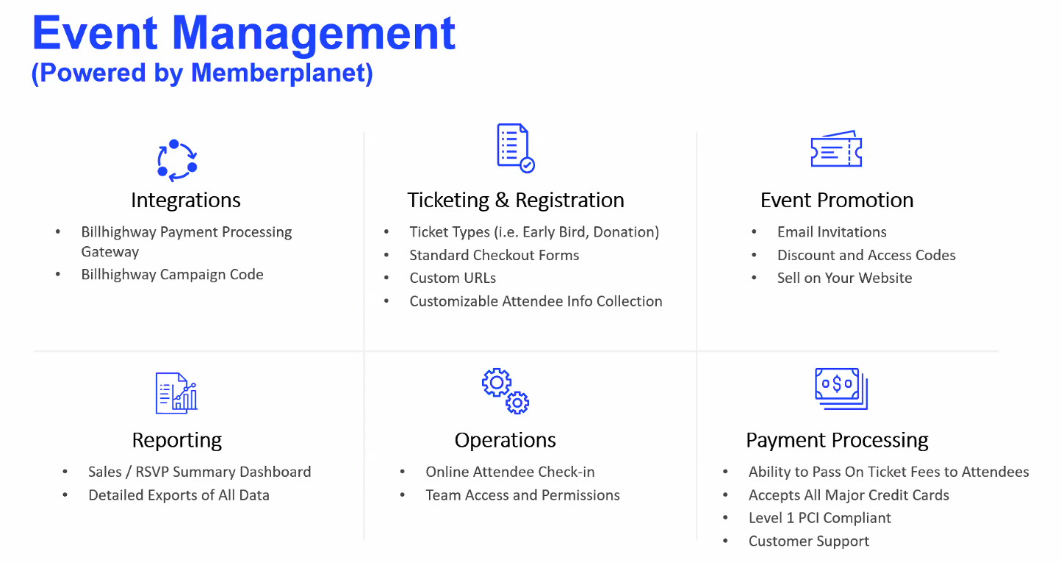
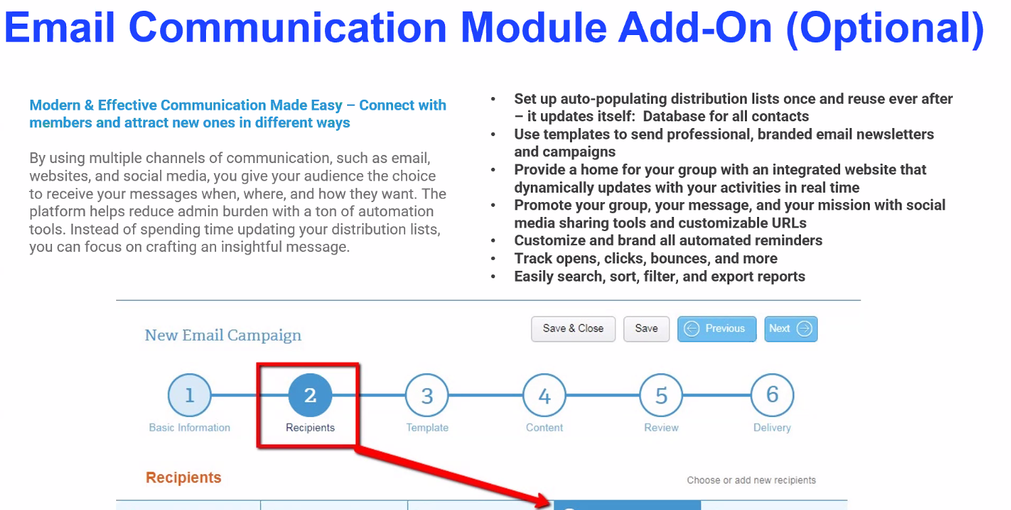
Standing Reports

- TREASURER [Joseph Chung] Treasurer Report November 2025.pdf
Cash Flow Statement - Month of November 2025
- $505.26 Event Revenue is 2025 PoE raffle sales cash
  - Microdeposits are from Joseph’s transfer setup, will deposit directly at Verity in Auburn post-events moving forward
- $4,925.34 Scholarship Fund revenue is transfers of 2025 PoE raffle sales and 2025 Golf Tourney revenue split
  - Consider better way given that we transfer back to Checking when issuing Scholarship checks
- $2,741.89 Event Expenses is transfer of 2025 PoE raffle sales (including Square), reimbursement to Tim Pochop of 2023 and 2025 Kitsap Socials, and 2026 MTA venue down payment

2025 Budget - Running Totals
- Need better way to track budget/actual revenue and expenses for MTA and PoE given they often overlap years and show skewed numbers

Miscellaneous
- Justin to transfer Seattle’s 2024 PoE revenue split to Scholarship (closed out in August)
- Seth to deposit $3,321.77 check for 2025 MTA revenue split
- Justin to coordinate 2025 PoE revenue split with Mt Tacoma and transfer Seattle’s to Scholarship
- William to send $1.00 check to Justin for 2025 YP Boots & Brews reimbursement error (Justin wrote out $315.16 numerically, but accidentally spelled out $316.16 in words)
- Justin to work on State Corporate/Charity Registration

- MEMBERSHIP [Jonathan Owen]
  - 435 individual members down 9 from November
  - 58 company members down 8 from November
  - 30 individual members in grace period (expirations in September or October)
  - 8 companies in grace period
  - 19 recently lapsed individual members (expirations in September)
  - 2 recently lapsed companies
  - 13 new members in September and October.
  - Action items for me: reaching out to recently lapsed/grace period members. Split for projects of excellence.

- PROGRAMS [Valerie Wade, Josh Hamon]
  - Debriefs
    - Toys for Tots was successful
    - Missed out on having the marines due to fallout from the shutdown
    - Good attendance and food
  - SAME Programs | Sip & Strategize [Faith, William, Zach]
  - Annual Events
    - December 2, 2025 | Holiday Social | POC Zachary Pesicka
    - December 9, 2025 | Emergency Management Panel | POC Valerie Wade/Josh Hamon -> Need attendees!
    - January 22, 2026 | Meet the Agencies | POC Kevin Stoll
    - February XX, 2026 | TBD
    - March XX, 2026 | TBD
    - April XX, 2026 |Small Business Symposium/Meet the Chiefs | TBD. POC is Zach Pesicka/Valerie/Lydia Griffey.
        - Shift the schedule for next year due to proximity of SAME JETC in Portland next May. (All 3 Post Presidents agreed to combine SBS and MTC into a two-day event at Seatac in April 2026.)
    - Need a June/July event for Board installation. Use the Summer Social?
    - October XX, 2026 | Projects of Excellence | POC Jason Hu | Marriott SeaTac

- YOUNG MEMBER PROGRAMS [William Shelton/Mitch Pastizzo]
  - Debriefs
  - Look ahead / Planning
    - Quarterly events - Total Annual budget of $3,000
    - Q4 Event - Looking for Host, maybe WSP (either Seattle or Tacoma)?
    - Young member group mailing list is now up to 80 Looking to do more of these events for Young Members

Committee Updates

- COMMUNICATIONS (Melissa Grasso)
- Reminder to plan to allow for a couple of weeks to process communications requests.
- Need Eventbrite access for more members
- Look at posting on social media (Liam willing to help out with posting).
- Engage to replace Google Drive as our file storage platform (Melissa).
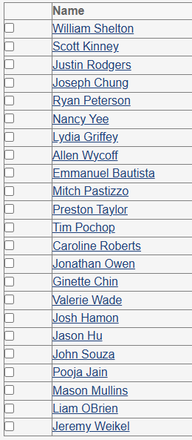
  - Library structure set up, invitations sent out by Melissa
  - 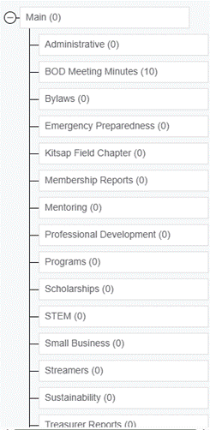

- EMERGENCY PREPAREDNESS (Jeremy Weikel) –

- ENERGY AND SUSTAINABILITY (Liam O’Brien) – Liam working on a Sustainability event. Was able to meet with the ASCE Sustainability Chair (thank you to Mason Mullins who provided the introductions) who has recently revived their sustainability program. Liam believes that some collaborative events with their team throughout the year would prove educational and generate some good content through their connections. These are yet to be scheduled, but once they are, he'll be sending notices out to the group.
  - As of right now, some quarterly presentations for sustainability talks with Federal entities are what I'm thinking can generate some content to fill the calendar in the meantime. some ideas for what those talks will be centered around are below:
    - USACE Seattle District – flood risk management, water quality, ecosystem restoration, climate adaptation.
    - NAVFAC Northwest – energy resilience, net-zero goals for installations, electrification of fleet and facilities.
    - U.S. Coast Guard D13 – coastal resilience, pier/port modernization, emergency response readiness.
    - EPA Region 10 – environmental compliance, 6PPD-Q mitigation, runoff management.
- ENGINEERING & CONSTRUCTION CAMPS (Alan Wycoff)

- KITSAP CHAPTER (Manny Bautista / Tim Pochop) – Set up quarterly lunch and learn sessions. Develop an annual schedule.

- STEM/UW STUDENT CHAPTER (Mason Mullins) –
- NOMINATIONS (Allen Wycoff) –
  - Open Positions
    - Professional Development
    - Leadership Development
    - Community Outreach
  - Committee Chairs for 2025-2026: SAME Seattle BOD list_2025_07_01.xlsx
- SCHOLARSHIPS (John Souza) –
  - Briefed on PSE&SSF scholarships and sponsorship opportunities (see New Business above).
  - 2026 schedule starts in Feb.
- SMALL BUSINESS COMMITTEE (Nancy Yee/Pooja Jain) -
- STRATEGIC PLANNING AND STREAMER AWARDS (Lydia Griffey) -
- VETERANS ASSISTANCE (Jason Hu)
  - HoH cohort (26-2) is releasing resumes to host companies on 24FEB, with placement selections due 26MAR for a fellowship from 11MAY-23JUL.
  - If your companies have any interest in accepting fellows through this program, Jason is happy to walk you through it.
  - HDR just hired a vet out of the Air Force from the last fellowship cohort that Jason mentored whoop whoop!

