SAME Seattle Post
Board Meeting - Agenda - Thursday February 5, 2026
Time: 8:00 am – 9:00 am
* Voting Board member

Name | Position | In Attendance
Robert Schlesinger* | Post President | X
Faith Powell | Immediate Past Post President
Fred Barker* | Post 1st VP | X
Zachery Pesicka* | Post 2nd VP
William Shelton* | Young Professionals VP | X
Scott Kinney* | Secretary
Justin Rodgers* | Treasurer | X
Joseph Chung | Assistant Treasurer | N
Ryan Peterson* | Post Director (2023-2026)
Nancy Yee* | Post Director (2023-2026)/Small Business Committee Co-Chair
Lydia Griffey* | Post Director (2024-2027) - Strategy/Streamers/Awards POC/Meet the Chiefs Chair
Al Wycoff* | Post Director (2024-2027)/Nominations Committee Chair/Engineering & Construction Camps Committee | X
Manny Bautista* | Post Director (Fellows) (2024-2027)/Post Fellows POC | X
Mitch Pastizzo* | Post Director (Young Professional) (2025-2028)/Young Professionals Committee Chair | X
CAPT Preston Taylor | Appointed Director (2025-2026) | X
Melissa Grasso | Communications/Post Web Master | X
Tim Pochop | Kitsap Chapter/STEM/Student Chapter | X
Caroline Roberts | Leadership Development
Jonathan Owen | Membership Chair | X
Ginette Chin | Mentoring
Valerie Wade | Programs Chair
Josh Hamon | Programs Asst. Chair
Jason Hu | Meet The Agencies Committee Chair/Projects of Excellence Committee Chair/Veterans Assistance Chair
John Souza | Scholarships
Tony Roos | Regional Vice President | X
Pooja Jain | Small Business Committee Co-Chair | X
Mason Mullins | UW Student Chapter Liaison
Liam O’Brien | Sustainability Chair/Social Media
Jeremy Weikel | Emergency Preparedness Committee Chair | X
Cheyne Lee | Guest | X
Michael Hatcher | Guest | X

Welcome and Announcements
- Roll call (see page 1).
- Declare quorum (4 voting members required).
- Approval January 8 2026 Minutes SAME Seattle Post Board Minutes - 2026_01_08 Approved
- Approval February 5, 2026 Agenda. Approved
- Announcements - introduce guests -> Welcome Cheyne and Michael
- Old Business
  - SAME re:Members software (aka Billhighway) rollout 1/12/2026
    - Consolidated financial platform for Posts: Payment Processing, Banking (FDIC insured), Spend Management, Finance & Accounting -> a bit more expensive than expected
    - Financial training 1/6/2025 1200-1330 PST
    - Events + Communications training 1/13/2026 1200-1300 PST
    - Training will be recorded and available in the training resource center.
  - 2026 Budget approved at last meeting - execute!
  - Meet the Agencies 1/22/2026 - report out
  - Meet the Chiefs/Small Business Symposium - having difficulty getting a commitment from USACE NWD
    - Look at making April happen
    - Get venue and commitments from Army
  - Audit of Post Financials (Al Wycoff, Ryan Peterson, Mason Mullins) due this month
  - We still need Post approval of Bylaws changes - when?

- New Business
  - APEX Alliance NW Conference March 26, 2026 Tacoma Convention Center - need volunteers Home - Alliance Northwest
    - Look to sign people up for shifts to break it up
  - 2026 Seabee Ball “Blueprints to the Future” March 7, 2026 @ Kitsap Conference Center, 1730-??, Black tie.
    - Help publicize and attend
    - There is a link and speaker already

Standing Reports

- TREASURER [Justin Rodgers] https://drive.google.com/file/d/10o81JpjgBsL9s3yYI-1ghq3zB-Z5LQar/view?usp=drive_link
  - Approved!

Action Items
- Joseph to schedule half-hour meeting with Bob, Fred and Justin to iron out log-ins for WA Department of Revenue and Constant Contact
- Justin to transfer Seattle’s 2024 PoE revenue split to Scholarship (closed out in August)
- Justin to coordinate 2025 PoE revenue split with Mt Tacoma and then transfer Seattle’s to Scholarship
- William to send $1.00 check to Justin for 2025 YP Boots & Brews reimbursement error (Justin wrote out $315.16 numerically, but accidentally spelled out $316.16 in words)
- Joseph to get Nancy’s supplies to Josh before MTA

- MEMBERSHIP [Jonathan Owen]
  - 405 individual members up 27 from January
  - 60 company members up 3 from January
  - 54 individual members in grace period (expirations in December or January)
  - 4 companies in grace period
  - 8 recently lapsed individual members (expirations in November)
  - 2 recently lapsed companies
  - 13 new members in December and January.

- PROGRAMS [Valerie Wade, Josh Hamon]
  - Annual Events
    - February 27, 2026 | Kitsap Chapter Lunch & Learn (AI in Construction Management) | POC Tim Pochop

    - March XX, 2026 | TBD
    - April XX, 2026 |Small Business Symposium/Meet the Chiefs | POCs Valerie Wade (SBS) and Lydia Griffey (MTC).
        - For 2026, we will combine these two events into a single, two-day program.
        - Anticipate ~300 attendees
    - Need a June/July event for Board installation. Use the Summer Social?
    - October XX, 2026 | Projects of Excellence | POC Jason Hu | Marriott SeaTac
    - December XX, 2026 | Holiday Social | POC Zachary Pesicka

- YOUNG PROFESSIONALS PROGRAMS [William Shelton/Mitch Pastizzo]
  - Debriefs
  - Look ahead / Planning
    - Quarterly events - Total Annual budget of $3,000
    - Q1 Event - Open office event at Mott Macdonald (looking at middle to end of March)
    - Q2
    - Q3 -> Boots and Brews
    - Q4 -> something local downtown
    - Young member group mailing list is now up to 80 Looking to do more of these events for Young Members

Committee Updates

- COMMUNICATIONS (Melissa Grasso)
- Reminder to plan to allow for a couple of weeks to process communications requests.
- Need Eventbrite access for more members
- Look at posting on social media (Liam willing to help out with posting).
- SAME Engage to replace Google Drive as our file storage platform (Melissa).
  - Library structure set up, invitations sent out by Melissa

- EMERGENCY PREPAREDNESS (Jeremy Weikel) –

- ENERGY AND SUSTAINABILITY (Liam O’Brien) – Liam working on a Sustainability event. Was able to meet with the ASCE Sustainability Chair (thank you to Mason Mullins who provided the introductions) who has recently revived their sustainability program. Liam believes that some collaborative events with their team throughout the year would prove educational and generate some good content through their connections. These are yet to be scheduled, but once they are, he'll be sending notices out to the group.

- ENGINEERING & CONSTRUCTION CAMPS (Allen Wycoff). Application deadline 3/11/2026
  - Good discussion of benefits
  - Put together a working group

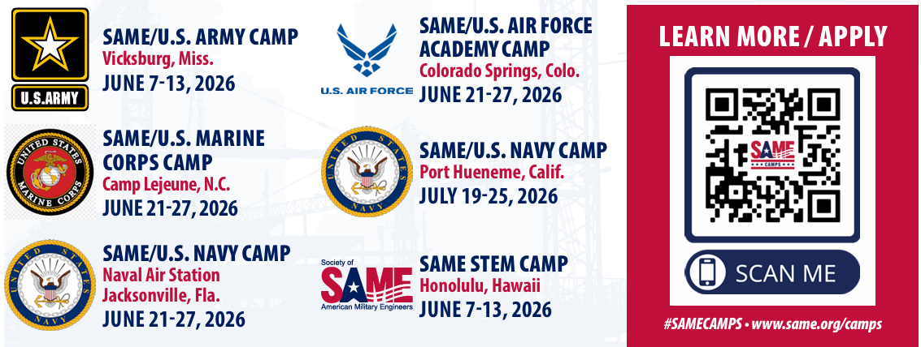

- KITSAP CHAPTER (Tim Pochop/ Manny Bautista) – Set up quarterly lunch and learn sessions. Develop an annual schedule.

- STEM/UW STUDENT CHAPTER (Mason Mullins) –
- NOMINATIONS (Allen Wycoff) – time to start prepping for July 2026! Second VP and 2 Board Director vacancies coming up.
  - Open Positions
    - Professional Development
    - Leadership Development
    - Community Outreach
  - Committee Chairs for 2025-2026: SAME Seattle BOD list_2025_07_01.xlsx
- SCHOLARSHIPS (John Souza) –
  - 2026 schedule starts in Feb.
- SMALL BUSINESS COMMITTEE (Nancy Yee/Pooja Jain) -
- STRATEGIC PLANNING AND STREAMER AWARDS (Lydia Griffey) -
- VETERANS ASSISTANCE (Jason Hu)

