SAME Seattle Post
Board Meeting - Minutes - Thursday March 5, 2026
Time: 8:00 am – 9:00 am
* Voting Board member

Name | Position | In Attendance
Robert Schlesinger* | Post President | Y
Faith Powell | Immediate Past Post President
Fred Barker* | Post 1st VP | Y
Zachery Pesicka* | Post 2nd VP
William Shelton* | Young Professionals VP | Y
Scott Kinney* | Secretary
Justin Rodgers* | Treasurer
Joseph Chung | Assistant Treasurer | Y
Ryan Peterson* | Post Director (2023-2026) | Y
Nancy Yee* | Post Director (2023-2026)/Small Business Committee Co-Chair
Lydia Griffey* | Post Director (2024-2027) - Strategy/Streamers/Awards POC/Meet the Chiefs Chair
Al Wycoff* | Post Director (2024-2027)/Nominations Committee Chair/Engineering & Construction Camps Committee
Manny Bautista* | Post Director (Fellows) (2024-2027)/Post Fellows POC
Mitch Pastizzo* | Post Director (Young Professional) (2025-2028)/Young Professionals Committee Chair
CAPT Preston Taylor | Appointed Director (2025-2026)
Melissa Grasso | Communications/Post Web Master
Tim Pochop | Kitsap Chapter/STEM/Student Chapter | Y
Caroline Roberts | Leadership Development
Jonathan Owen | Membership Chair | Y
Ginette Chin | Mentoring
Valerie Wade | Programs Chair | Y
Josh Hamon | Programs Asst. Chair | Y
Jason Hu | Meet The Agencies Committee Chair/Projects of Excellence Committee Chair/Veterans Assistance Chair | Y
John Souza | Scholarships | Y
Tony Roos | Regional Vice President
Pooja Jain | Small Business Committee Co-Chair | Y
Mason Mullins | UW Student Chapter Liaison
Liam O’Brien | Sustainability Chair/Social Media | Y
Jeremy Weikel | Emergency Preparedness Committee Chair | Y

Welcome and Announcements
- Roll call (see page 1).
- Declare quorum (4 voting members required).
- Approval February 5, 2026 Minutes SAME Seattle Post Board Minutes - 2026_02_05 -> Approved
- Approval March 5, 2026 Agenda. -> Approved
- Announcements - introduce guests
- Old Business
  - SAME re:Members software (aka Billhighway) rollout 1/12/2026
    - Consolidated financial platform for Posts: Payment Processing, Banking (FDIC insured), Spend Management, Finance & Accounting
    - Training was recorded and available in the training resource center SAME Training Homepage - Smartsheet.com
    - People have not investigated the platform as of yet
  - Audit of Post Financials (Al Wycoff, Ryan Peterson, Mason Mullins) due last month
  - We still need Post approval of Bylaws changes - when?
  - APEX Alliance NW Conference March 26, 2026 Tacoma Convention Center - need volunteers Home - Alliance Northwest
    - Look to sign people up for shifts to break it up
    - Pooja and Liam volunteered

- New Business
  - 2026 Seabee Ball “Blueprints to the Future” March 7, 2026 @ Kitsap Conference Center, 1730-??, Black tie.
    - Help publicize and attend
    - There is a link and speaker already
  - Post Annual Report due March 31
    - Scott to Champion Post Annual Report
  - Post Leaders Workshop in Scottsdale, AZ August 2-4
    - SAME National covers hotel & registration for two people
    - Who should we send? Josh Hamon is interested
      - Joseph
      - Pooja

Standing Reports

- TREASURER [Justin Rodgers] Treasurer Report Feb 2026.pdf
Action Items
- Joseph to schedule half-hour meeting with Bob, Fred and Justin to iron out log-ins for WA Department of Revenue and Constant Contact
- Justin to transfer Seattle’s 2024 PoE revenue split to Scholarship (closed out in August)
- Justin to coordinate 2025 PoE revenue split with Mt Tacoma and then transfer Seattle’s to Scholarship
- William to send $1.00 check to Justin for 2025 YP Boots & Brews reimbursement error (Justin wrote out $315.16 numerically, but accidentally spelled out $316.16 in words)

- MEMBERSHIP [Jonathan Owen]
  - 434 individual members up 29 from February
  - 63 company members up 3 from February
  - 21 individual members in grace period (expirations in January or February)
  - 2 companies in grace period
  - 15 recently lapsed individual members (expirations in December)
  - 0 recently lapsed companies
  - 16 new members in January and February.
Look at blasting out emails to retain members

- PROGRAMS [Valerie Wade, Josh Hamon]
  - Annual Events
    - February 27, 2026 | Kitsap Chapter Lunch & Learn (AI in Construction Management) | POC Tim Pochop
        - Well received event
        - No recording available
    - April XX, 2026 |Small Business Symposium/Meet the Chiefs | POCs Valerie Wade (SBS) and Lydia Griffey (MTC).
        - For 2026, we will combine these two events into a single, two-day program.
        - Anticipate ~300 attendees
        - A lot of work left to do
        - Soliciting volunteers to help out -> Fred is volunteering
        - Note that event agreements need to be approved by Board President
        - Do we want to modify bylaws to allow a certain threshold to be executed by other BOD members?
    - Need a June/July event for Board installation. Use the Summer Social
        - Establish a committee to set up the installation
    - August xx, 2026 - Golf Tournament
    - October XX, 2026 | Projects of Excellence | POC Jason Hu | Marriott SeaTac
    - December XX, 2026 | Holiday Social | POC Zachary Pesicka

- YOUNG PROFESSIONALS PROGRAMS [William Shelton/Mitch Pastizzo]
  - Debriefs
  - Look ahead / Planning
    - Quarterly events - Total Annual budget of $3,000
    - Q1 Event - Open office event at Mott Macdonald (looking at middle to end of March)
    - Q2
    - Q3 -> Boots and Brews
    - Q4 -> something local downtown
    - Young member group mailing list is now up to 80 Looking to do more of these events for Young Members

Committee Updates

- COMMUNICATIONS (Melissa Grasso)
- Reminder to plan to allow for a couple of weeks to process communications requests.
- Need Eventbrite access for more members
- Look at posting on social media (Liam willing to help out with posting).
- SAME Engage to replace Google Drive as our file storage platform (Melissa).
  - Library structure set up, invitations sent out by Melissa

- EMERGENCY PREPAREDNESS (Jeremy Weikel) – Working on setting up an Emergency Operations Center (EOC)
  - Working on table-topping exercise
  - Great American Shakeout

- ENERGY AND SUSTAINABILITY (Liam O’Brien) – Liam working on a Sustainability event. Was able to meet with the ASCE Sustainability Chair (thank you to Mason Mullins who provided the introductions) who has recently revived their sustainability program. Liam believes that some collaborative events with their team throughout the year would prove educational and generate some good content through their connections. These are yet to be scheduled, but once they are, he'll be sending notices out to the group.
  - Looking at setting up a panel / lunch and learn

- ENGINEERING & CONSTRUCTION CAMPS (Allen Wycoff). Application deadline 3/11/2026 STEM/Engineering & Construction Camps - SAME
  - We are sponsoring campers
  - Deadline for submissions coming up
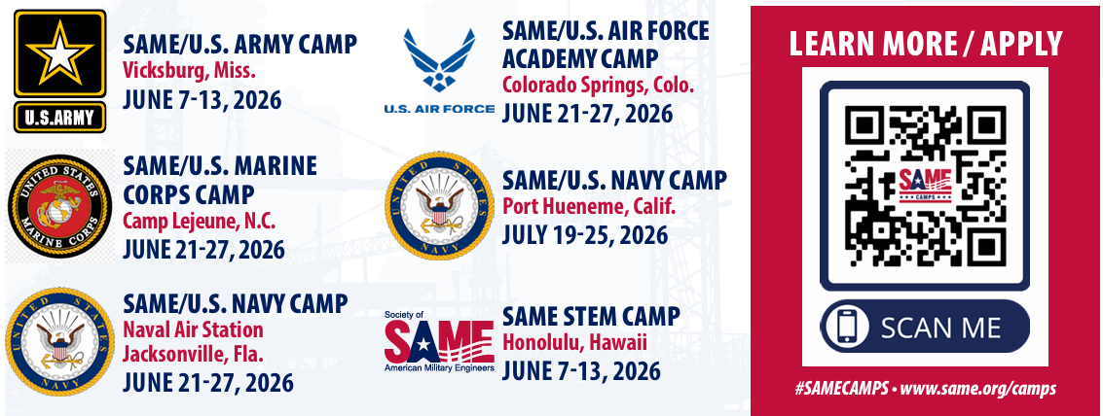

- KITSAP CHAPTER (Tim Pochop/ Manny Bautista) – Set up quarterly lunch and learn sessions. Develop an annual schedule.
  - Case studies of construction projects where things went awry

- STEM/UW STUDENT CHAPTER (Mason Mullins) –
- NOMINATIONS (Allen Wycoff) – time to start prepping for July 2026! Second VP and 2 Board Director vacancies coming up.
  - Open Positions
    - Professional Development
    - Leadership Development
    - Community Outreach
  - Committee Chairs for 2025-2026: SAME Seattle BOD list_2025_07_01.xlsx
- SCHOLARSHIPS (John Souza) –
  - 2026 schedule starts in Feb.
- SMALL BUSINESS COMMITTEE (Nancy Yee/Pooja Jain) -
- STRATEGIC PLANNING AND STREAMER AWARDS (Lydia Griffey) -
- VETERANS ASSISTANCE (Jason Hu)

