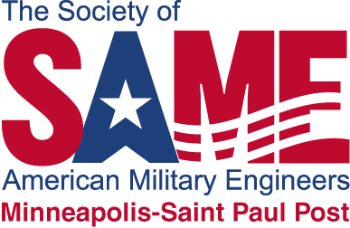

Society of American Military Engineers (SAME)
Educational Grant for Math and Science Grades K-12

The Society of American Military Engineers (SAME) is offering educational grants for up to $3,000.00 for elementary and secondary schools for the upcoming 2025-2026 school year for schools within a 100-mile radius of Saint Paul, Minnesota. Additionally, a school can apply for the grant in coordination with a SAME MSP member as a sponsor / facilitator, even though they are outside of the 100-mile radius.

One fundamental goal of SAME is… To promote an understanding of, and appreciation for, the engineering related disciplines and to help the young people in our communities be better prepared to become our future engineers… The Minneapolis - St Paul Chapter of SAME is requesting applications from schools and classroom teachers who are committed in supporting the math and sciences that support future engineering-related career opportunities. We are encouraging all grade levels to participate.

Applications for these grants will be reviewed on the following criteria:

- Creativity and quality of proposed project
- Demonstrated demand or need for the project
- Support of the Minnesota or Wisconsin math and/or science academic standards

Applications are due May 1, 2026.

Elementary and secondary teachers / schools that are promoting the math and sciences are encouraged to apply.

The application forms are posted on the SAME website. For application forms and a listing of the historical grants awarded go to:

……………..Link to website be placed here………….….

